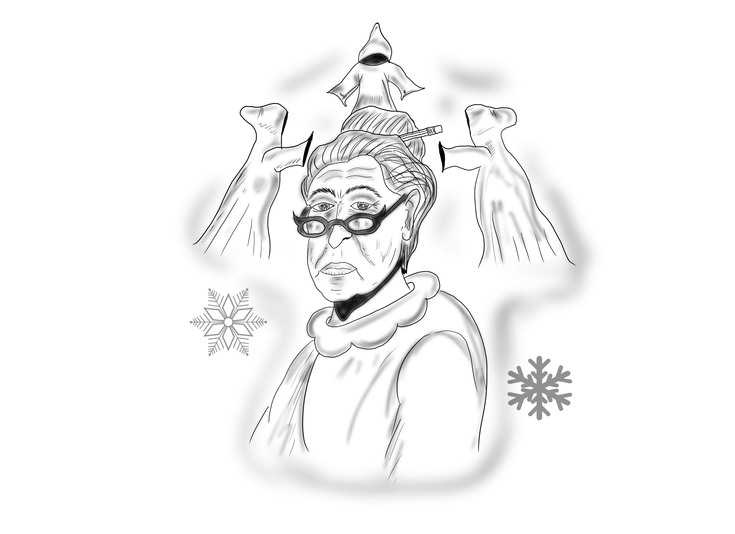

Holiday Show

By

Johnnie Cochran Middle School

Ms. Battleaxe:

A Christmas Carol