Baby Polar Bears

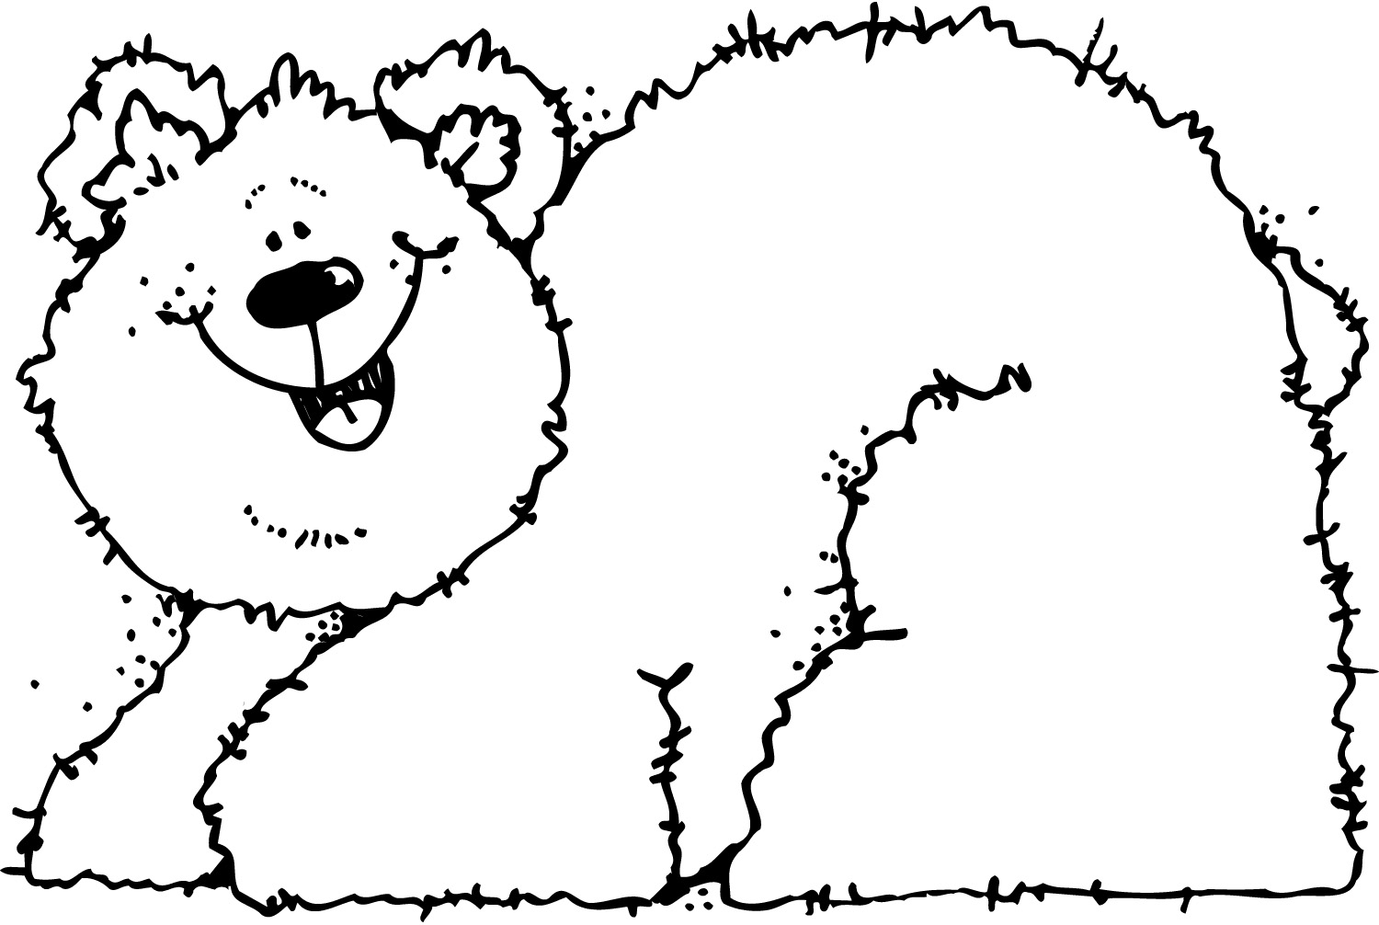

Polar bears live in ice and snow. A polar bear baby is a cub. A cub is born with its eyes closed. It does not have a lot of fur. A cub drinks its mother’s milk. The mother polar bear keeps the cub warm.
The cub grows bigger. Soon the cub can walk. It grows thick, white fur. The cub’s mother shows it how to hunt for food. She shows it how to swim. She plays with her cub in the snow.
The cub grows stronger. The cub learns to swim. It can find its own food. Now the cub can live by itself.

- What is a polar bear like when it is first born? Circle your answer, then highlight the sentences in the passage that let you know your answer is correct.
  - It likes to play in the snow.
  - Its eyes are closed and it does not have much fur.
  - It can swim and find its own food.
- How is a polar bear cub different from a mother polar bear? Write your answer or draw a picture to show your answer.
________________________________________________________
------------------------------------------------------------------------------------
__________________________________________________________________________________________
________________________________________________________
------------------------------------------------------------------------------------
__________________________________________________________________________________________

- If a polar bear cub can walk, swim, and play, what do we know about the cub?
  - The cub was just born.
  - The cub grew bigger since it was born.
  - The cub cannot live in ice and snow.
- What is a cub able to do when it lives by itself?
________________________________________________________
------------------------------------------------------------------------------------
__________________________________________________________________________________________
________________________________________________________
------------------------------------------------------------------------------------
__________________________________________________________________________________________

- What is the passage mostly about?
  - ice and snow
  - polar bear cubs
  - learning to hunt and swim
Baby Polar Bears: Teacher Copy

Polar bears live in ice and snow. A polar bear baby is a cub. A cub is born with its eyes closed. It does not have a lot of fur. A cub drinks its mother’s milk. The mother polar bear keeps the cub warm.
The cub grows bigger. Soon the cub can walk. It grows thick, white fur. The cub’s mother shows it how to hunt for food. She shows it how to swim. She plays with her cub in the snow.
The cub grows stronger. The cub learns to swim. It can find its own food. Now the cub can live by itself.

- What is a polar bear like when it is first born? Circle your answer, then underline the sentences in the passage that let you know your answer is correct.
RI.1.1 ~ Ask and answer questions about key details in a text.
CCR1 ~ Read closely to determine what the text says explicitly and to make logical inferences from it; cite specific textual evidence when writing or speaking to support conclusions drawn from the text.
  - It likes to play in the snow.
  - Its eyes are closed and it does not have much fur.
  - It can swim and find its own food.

- How is a polar bear cub different from a mother polar bear? Write your answer or draw a picture to show your answer.
RI.1.3 ~ Describe the connection between two individuals, events, ideas, or pieces of information in a text.
Possible answers: Polar bear cubs can’t hunt by themselves and mother bears can. Polar bear cubs don’t know how to swim, and mother bears do know how to swim.

- If a polar bear cub can walk, swim, and play, what do we know about the cub?
RI.1.1 ~ Ask and answer questions about key details in a text.
CCR1 ~ Read closely to determine what the text says explicitly and to make logical inferences from it; cite specific textual evidence when writing or speaking to support conclusions drawn from the text.

  - The cub was just born.
  - The cub grew bigger since it was born.
  - The cub cannot live in ice and snow.

- What can a cub do when it is able to live by itself?
RI.1.1 ~ Ask and answer questions about key details in a text.
Possible answers: Polar bears that can live by themselves can hunt and get their own food. Polar bears that can live by themselves can swim.

- What is the passage mostly about?
  - ice and snow
  - how polar bear cubs grow up
  - learning to hunt and swim
RI.1.2 ~ Identify the main topic and retell key details of a text.
Teacher Directions:
Distribute pages 1 – 3 to each student. Depending on the level of your students, you can either:
- read the passage out loud to the class,
- allow students to read the passage independently, or
- do a choral reading,
After students have read the passage, read each question out loud to your students. Have each student complete their answers independently. For questions 2 & 4, students may draw their answers.

