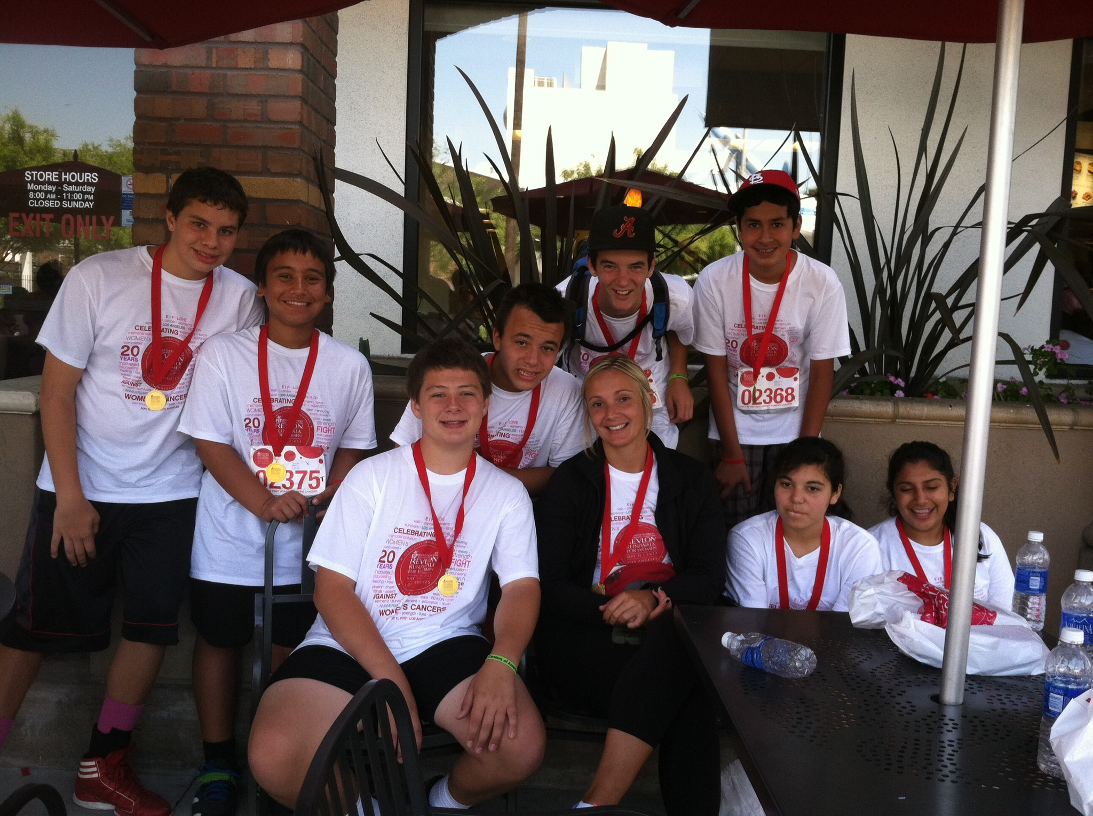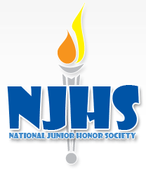

NJHS Chapter Meetings the first Tuesday of EVERY month in the 6th Grade Room:

**August 27**

**September 3**

**October 1**

**November 5**

**December 3**

**January 7**

**February 4**

**March 4**

**April 1**

**May 6**

**June 3 (7th grade only)**

2013-2014

NJHS Service Project, 2012-2013

The 2012-2013 St. John Eudes Chapter of NJHS chose to support the EIF Revlon 5K Run/Walk for Women and raised over $1500 to support cancer research . The nationally acclaimed Entertainment Industry Foundation Revlon Run/Walk for Women has touched the lives of millions of people through increased awareness, education, research, and diagnostic treatment services and the 2012-2013 members of NJHS were honored to be a part of such a wonderful program.

Congratulations to the 2013-2014 Members of the St. John Eudes Chapter of the National Junior Honor Society.

**8th Grade:**

Justin Mills

Cecil Ossa

Daniel Setiabudi

Daniel Singontiko

Matthew Yuhico

Jeremy Valtairo

**7th Grade:**

Olivia Andazola

Kawika Austin

Natalia Campos

Carlos Del Castillo

Daniel Ferreiro

Jessica Gullette

Michael Grijalva

Thayer Loomis

Caleb Martin

Kelan Martinez

Kristina Mendoza

Bianca Ruiz

Jennifer Uyanga

Madison Valerio

# NJHS News

National Junior Honor Society

Welcome to all of the 2013-2014 members of the St. John Eudes chapter of the National Junior Honor Society. For more information on NJHS please refer to Ms. Scheppers NJHS web page. http://sje6thgr.weebly.com/njhs.html

2013-2014 NJHS Induction Ceremony 2:00-3:00pm, Grill Hall

Sep. 10

Aug. 28

2013-2014 NJHS Parent/Student Contracts and Annual Membership Fees Due

### Reminders

August 2013

NJHS, St. John Eudes