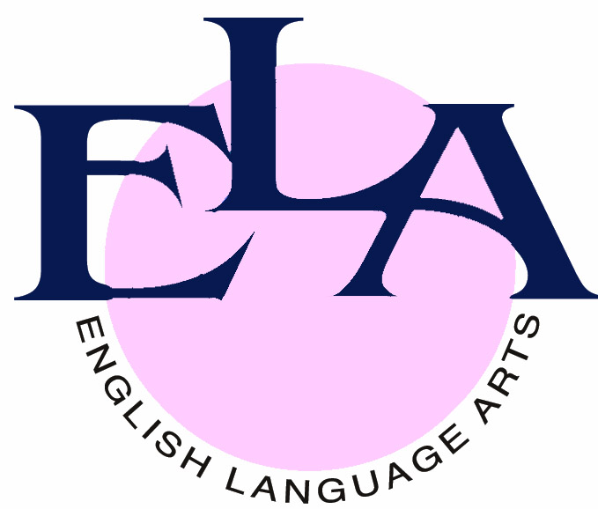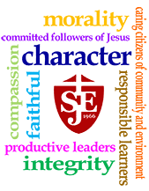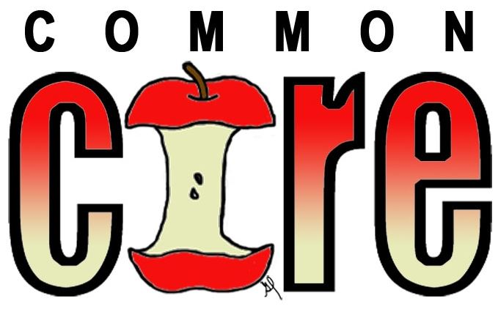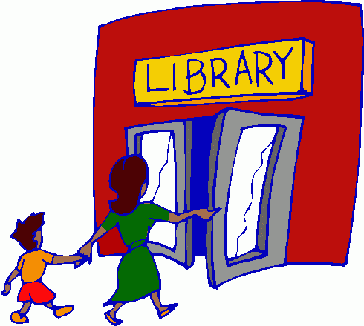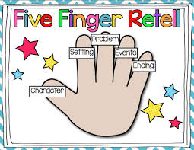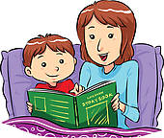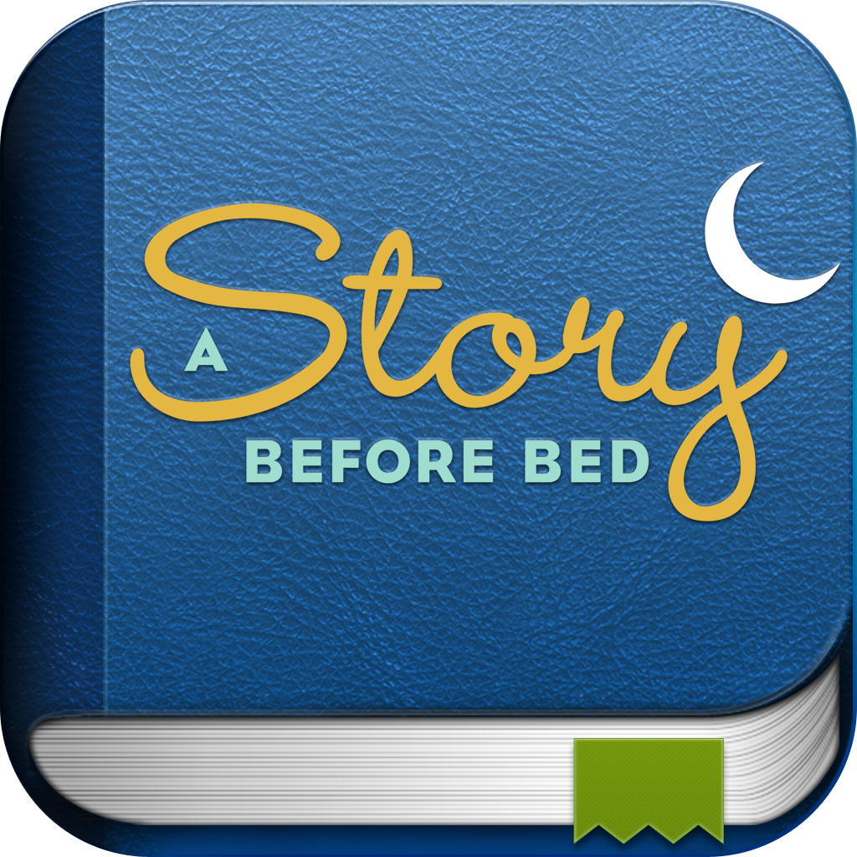

## **America’s schools are working to provide higher quality instruction than ever before.**

In English language arts and literacy, this means ***three major changes***.

1.) **Informational Text** - Students will continue reading and writing. But in addition to stories and literature, they will read more texts that provide facts and background knowledge in areas including science and social studies.

2.) **Textual Evidence** - Students will read more challenging texts and be asked more questions that will require them to refer back to what they have read.

3.) **Vocabulary in Context** - Students will also be an increased emphasis on building a strong vocabulary so that students can read and understand challenging material.

St. John Eudes is working to implement the Common Core Standards in order to improve teaching and learning to ensure that all children will graduate high school with the skills they need to be successful in order to be college and career ready in the 21st Century.

# 

January 14, 2014

Common Core Standards

Thank you to all of the parents who attended the PTSO General Meeting on Thursday, January 9.

FREE DRESS who the students of the parents who attended will be on Friday, January 24.

Reinforcing Common Core at Home

The Common Core State Standards are national standards that say what K-12 students are expected to learn in math and the English language arts. For older students, the standards expand to include literacy in history/social studies, science and technical subjects.

Despite the complexities of the standards, there are several basic ways parents can support their child's learning. The recommendations in the table provided line up with the four broad areas of the Common Core reading standards: Key Ideas and Details, Craft and Structure, Integration of Knowledge and Ideas, and Range and Level of Complexity.

***Helping Your Child Learn Outside of School***

**Grades K-3 (Early Readers)**

|  |  |  |
| --- | --- | --- |
| **Common Core**  **Reading Standard Strand** | **What it means:** | **How parents can help:** |
| **Key Ideas & Details** | Your child will be encouraged to carefully read many books and texts. Within these texts, your child will be working to understand what is happening, summarize key events or points and recall details important to the story or topic. | After you share a story, talk about important story elements such as beginning, middle and end. Encourage your child to retell or summarize the reading. After reading nonfiction, ask questions about the information, "Is the spider an insect? How is a spider different than an insect?" |
| **Craft and Structure** | The standards within this area (or "strand") focus on specifics within a book, for example, an author's specific word choices or phrases. A second emphasis relates to understanding the underlying structure of common types of texts, including storybooks, poems and more. | During and after reading, call attention to interesting words and phrases. This may include repeated phrases, metaphors or idioms ("sick as a dog," "a dime a dozen.") Talk about any new vocabulary and other ways the author used language or words to make the text interesting, informative, funny or sad. |
| **Integration of Knowledge and Ideas** | Within this strand, students will be working to compare and contrast details from stories, describe key ideas using details in informational text, and tell how two texts on the same topic differ. | For younger students, encourage your child to describe how the illustrations within a book support the story. For older students, have fun reading different versions of the same fairy or folk tale. Talk about the similarities and differences between the two books. Then switch to nonfiction and read two books on the same topic. Compare the information in each, again focusing on similarities and differences. "Let's look at each book and think about the words used to describe weather. How are the descriptions alike? How are they different?" |
| **Range of Reading and Level of Text Complexity** | Teachers will be using a variety of techniques to introduce a range of books and other written material that both support and challenge a child's reading level. This may include nonfiction and fiction, infographics, poetry and more. This will be done with the ultimate goal of making sure students understand what they're reading. | Parents can help promote their child's skill while developing their reading stamina (ability to "stick with it."). This means helping them avoid frustration or anxiety about tackling a harder book. Support your reader by talking through some of the things that make a text complex, including multiple levels of meaning, inferred information (implied rather than clearly stated) or more sophisticated graphics. |

### **Common Core State Standards**

1. Read to your child and have him or her read to you every day for at least 15 minutes. Pick out words that might be new to your child or words that have multiple or complex meanings. Discuss those words and how they add to what the writer is saying.

2. Ask your child to retell a story in his or her own words by telling what happened first, second, third, etc.

3. Ask your child to think about what the message of a story may be or what he or she learned from an informational book or article.

4. Look for opportunities in everyday places to build your child’s vocabulary.

5. Be sure your child has a library card. Children should select books in which they are interested to develop a passion for reading. Many libraries have book clubs and family activities that make reading fun for the entire family.

6. Use technology to help build your child’s interest in reading. There are several websites where students can read books or articles online. The computer will help with words the student cannot read independently. Libraries also have computers students can use to access those sites. Feel free to ask a librarian or teacher for suggestions.

***Helping Your Child Learn Outside of School***

**Grades K-3 (Early Readers)**

In this swiftly changing techy era, it's tough to sort through what apps are must-have. When it comes to sharing (or creating!) books with your kids, we've got you covered. Dig into this list of nifty and distinctive phone and tablet apps.

**1.**[**Tikatok StorySpark**](http://www.tikatok.com/)**.**From book behemoth Barnes & Noble, Tikatok StorySpark is aimed at your family’s pint-sized publisher. Kids write and illustrate their own books, using a catalog of art or their own photos or digital drawings for the backgrounds. When it’s ready, books are “published” under a chosen pen name and posted online at Tikatok.com. *iPad, iPhone, iPod Touch, Android; app is free, books are $3 each.*

**2.** [**Bookster**](http://www.imaginelearning.com/apps/bookster/)**.** Young readers can find new literary faves with helpful narration from kids their age. Your little ones will also learn new vocabulary words and can record themselves reading the books when they’ve finished! *iPad, iPhone, iPod Touch, Android; free with first e-book.*

**3.** [**Tales2Go**](http://www.tales2go.com/)**.** A Parents’ Choice Gold Award-winner that streams on-demand, unlimited access to more than 1,000 stories. Scroll through and sort by reader age, genre, and more. Bookmark and build a favorites list for easy return visits! *iPad, iPhone, iPod Touch; $10 per month.*

**4.** [**A Story Before Bed**](http://www.astorybeforebed.com/)**.** More than 300 stories in this app’s library for an interactive read-along experience with your child. Record video of storytime so that your little one can watch it again in the morning, while paging through and following along! *iPad, iPhone, iPod Touch; $10 per month.*

**5.** [**TouchyBooks**](http://www.touchybooks.com/)**.** Quirky sounds, animation, and flip-book usability offer a realistic experience and a touch of magic for toddlers and tweens. Use the easy star voting system to rate your favorites on this multilingual platform. *iPad,* *iPhone, iPod Touch, Android, Windows Phone; free with two free books.*

**6.**[**MeeGenius**](http://www.meegenius.com/)**.**Highlight words for review and use the MeeGenius audio playback to keep your little bookworms engaged. Give the personalization element a try, where a child can substitute his or her own name for that of a favorite character in the book! *iPad, iPhone, Android, Google TV; free with book selection.*

***Suggested Reading APPS***

***for Early Readers (Grades K-3)***

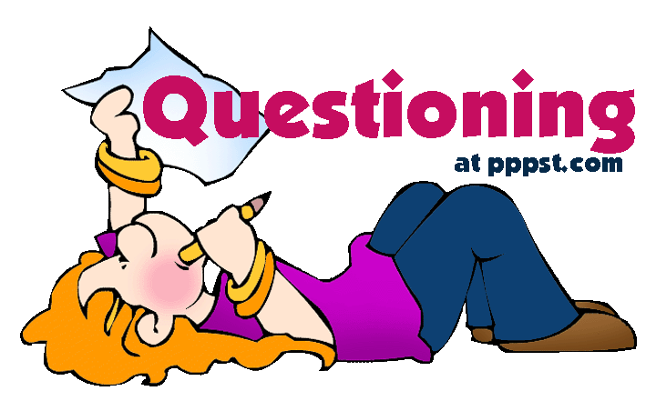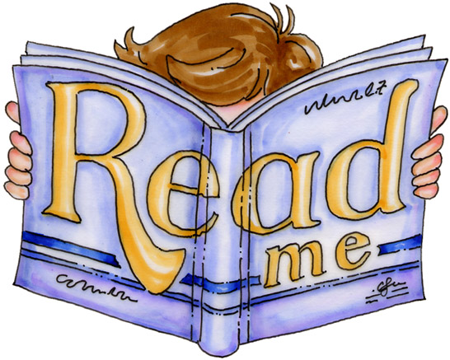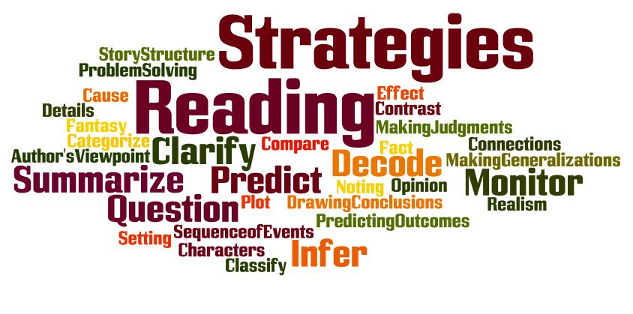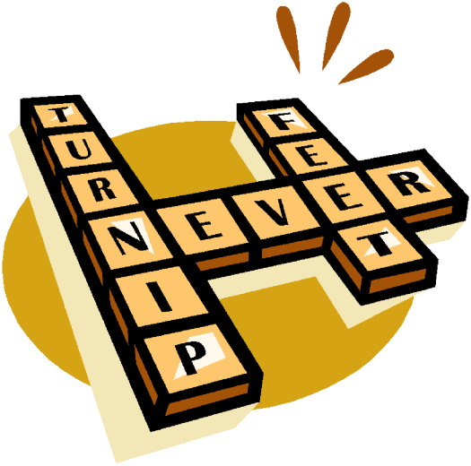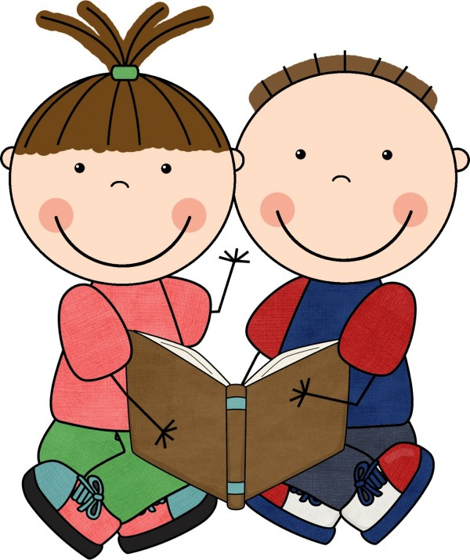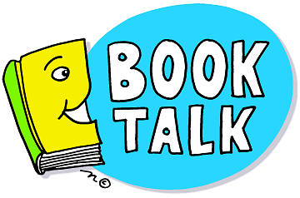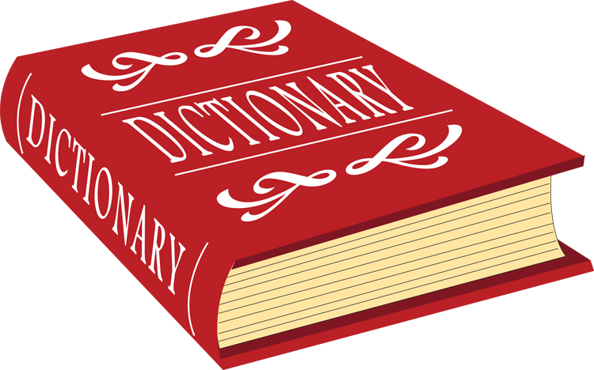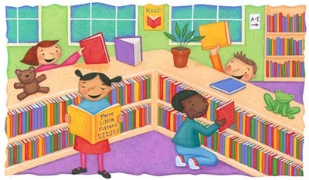

**3. Questioning** is a skill critical for developing reading comprehension. When we model questioning, we show children that it is super important to think about what they’re reading as they’re reading. After every few paragraphs or pages, model how you reflect on what you read:

“I wonder why . . .”

“What will happen to the . . .”

“Why is the little girl frowning in that picture . . .”

“How does the dog feel now that . . .”

**4. Making connections** draws readers closer to texts. They feel more in touch with characters, events, and ideas when they are able to find some basic similarities with them, and as a result, readers are more likely to remember what they read. Connecting is easy for young readers to do on their own. Model connecting by saying:

“I know how that character feels! I remember when I fell and hurt my knee . . .”

“We saw the very same sand crabs when we were at the beach last year. Remember?”

“You have a brother and a sister, just like Arthur.”

“You will start school in the fall, and we just read a book last week about Max who was starting at a new school.”

**5. Visualizing** is simply having readers picture, or visualize, what they are reading. Visualizing isn’t always necessary when reading richly illustrated children’s books, but when reading stories, poems, or articles that lack photos, parents can say:

“When I read these words, I can really feel the warm breeze blow through my hair.”

“Close your eyes, and tell me what you see when I read this poem. What pictures does it put in your mind?”

**Six Tips to Improve Reading Comprehension in Your Early Reader:**

**1. Have them read aloud.** Reading aloud allows the child to see the words as well as hear them which enables them to process what they are reading.

**2. Provide the right kinds of books.** The child should recognize at least 90% of the words in the text without any help to independently read a text successfully.

**3. Reread to build fluency.** To gain meaning and encourage comprehension a child needs to read quickly and smoothly. Rereading familiar books allows for practice.

**4. Talk to the teacher.** Ask questions about what your child is reading, their strengths and weaknesses.

**5. Supplement class reading.** Look for easy-to-read magazines or informational text on topics studied in class to provide your student with knowledge and aid comprehension.

**6. Talk to your child about what they are reading.** “Verbal processing” enables a child to remember and think through what they have read.

***Practicing Reading Strategies at Home with Early Readers***

Parents can incorporate reading strategy work on the fly, at any time, with little to no prep at all. All parents need are just a few key words and phrases to keep in their back pocket to pull out during time spent reading with kids.

**1. Predicting** is simply making a logical guess about a story or article before the text is read. Model predicting by:

* Examining the cover of the book and talking about the book’s title before reading. Say, “The title of the book is *Stranger in the Woods*, and on the cover I see two deer looking at a snowman. My guess is that the snowman will be the ‘stranger in the woods.’  Let’s see.”
* Stopping midway though a book and saying, “Okay, I know that Lucky the dog keeps following the leprechaun. Will the leprechaun ever be nice to that poor dog? I bet they’ll be friends by the end.”

**2. Activating schema** just means that you’re getting children to think about what they already know about a subject before they read or talk about the topic. You can activate schema by:

Saying, “The book we’re going to read is called Penguin Puzzle, and it looks like it’s about penguins. I know that penguins live in cold areas and that they can’t fly. What can you remember about penguins?”

**17 Ways to Keep Your Student Turning the Page (Grades 4-8)**

Amidst the flurry of friends, homework, and hormones, your pre-teen may not feel like reading. Tips for keeping their interest and skills on track.

**1. Let your child choose what to read.** While you may cringe at their preferences, they may never touch a title if it's force-fed.

**2. Talk about what she reads.** Ask them what they think of a book and make connections with ideas or issues that are relevant to their life.

**3. If he's struggling or bored with a book, let him put it down.** Forcing them to stick with a difficult or dull book that's intended for pleasure will reinforce the idea that reading is a chore.

**4. Subscribe to magazines that will interest her.** Ask them to choose one or two titles and put the subscription in their name.

**5. Read the newspaper together.** Whether it's for 15 minutes over breakfast or on weekends, establish a routine and discuss what you each read.

**6. Be flexible with bedtime and chores when your child is reading.** Within reason, avoid asking your child to stop reading.

**7. Play games that utilize reading.** Word- and vocabulary-building games like Scrabble or Boggle are great, but many board games provide reading opportunities (even if it's just the instructions). Crosswords provide opportunities for learning new words and spelling practice, too.

**8. Encourage your middle-schooler to read to a younger sibling.** Letting them take over ritual reading at bedtime once a week will ensure they read something, and they may find their sibling's enthusiasm for stories contagious.

**9. Visit the library together.** Try to make it an event where you share some quality one-on-one time and both choose a few books.

**10. Find an outlet for your child to "publish" a book review.** When they finish a book, encourage them to write it up for a family or school newspaper, magazine, or web site. They could also try posting a review at a local bookseller or an online retailer.

**11. Ensure they have a good reading space.** They should choose where it is, but you can make sure it's well lit and inviting so they stay a while.

**12. Keep up on what they’re reading.** If you can, read a few pages of their books yourself so you can discuss them with your child.

**13. Encourage writing.** Whether it's via snail- or e-mail, suggest that they keep in touch with distant friends or relatives. Keeping a journal or chronicling a family vacation will also provide reading practice.

**14. Provide a good dictionary.** They may not want to ask for your help with words anymore, so make sure they have a good reference.

**15. Suggest books from movies they liked.** They may enjoy getting even more detail in the book.

**16. Listen to books on tape in the car.** If you're heading on vacation, or even back-and-forth to school, try listening to a novel that will appeal to everyone.

**17. Model reading.** Your pre-teen will still follow your reading habits (though they'll never let you know it!). Let them see you reading, make comments, and share interesting passages with them.

**Searching for Literary Texts Aligned with Common Core State Standards**

**Check out these websites…**

**Booksource** offers suggested grade level texts by genre and according to Common Core State Standards: <http://www.booksource.com>

**Johns Hopkins University Center for Talented Youth** Suggested Reading offers a variety of genres and books for students to choose from: <http://cty.jhu.edu/talent/after/reading/grades5-6.html>

**Barnes & Nobles** offers a variety of age appropriate suggestions as well as a program where students may download a B&N Reading Journal and earn *FREE* books: <http://www.barnesandnoble.com>

**Newbery Medal Winners** has a variety of award winning reading recommendations: <http://www.ala.org/alsc/awardsgrants/bookmedia/newberymedal/newberyhonors/newberymedal>

**Scholastic** has age appropriate reading selections by genre available at: <http://www.scholastic.com/kids/stacks/books/?lnkid=stacks/nav/b_and_a/main>

***When purchasing a book or looking through reading lists…***

1.) Take the time to discuss book selections with your child and review their choices.

2.) Do your homework…research the novel and read reviews to decide if the text is appropriate for your child.

3.) Ensure that reading material aligns with your family values.

***Helping Your Child Learn Outside of School***

**Grades 4-8**

1. Provide time and space for your child to read independently. This time should be free from distractions such as television.

2. Ask your child what topics, events, or activities he or she likes. Then look for books, magazines, or other materials about those topics that would motivate your child to read.

3. It is also helpful when your child sees other people reading at home. You could share what you have read.

4. Make time for conversation at home. Discuss current events, shared interests, and future aspirations for education and career.

5. Visit museums, zoos, theaters, historical sites, aquariums, and other educational places to help increase your child’s exposure to new knowledge and vocabulary.

6. Use technology to help build your child’s interest in reading. There are several websites where students can read books or articles online. The computer will help with words the student cannot read independently. Libraries also have computers students can use to access those sites. Feel free to ask a librarian or teacher for suggestions.