Reading Concepts & Strategies
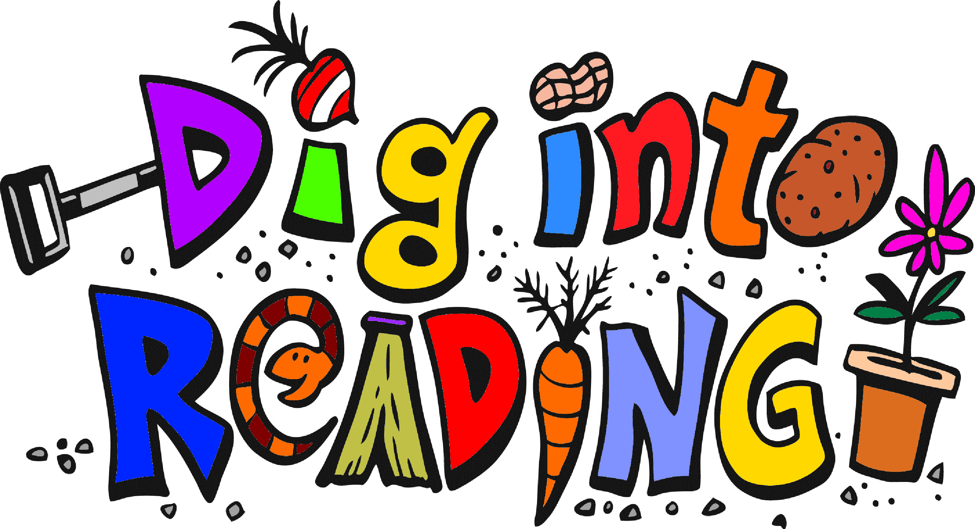
Author’s Perspective: The reason why an author has written a text for readers.

Character: The looks, traits, thoughts, and relationships of a person, animal or object with life-like qualities in a text.

Classify & Categorize: To arrange or organize details from a text into groups with similar traits (categories), and to name or label that group (classify).

Compare & Contrast: How two or more things are alike (compare) and how they are different (contrast).

Drawing Conclusions: Combing background knowledge, personal experience and textual information to determine meaning.

Explicit Information: Details that can be clearly found “right there” in the text.

Fact and Opinion: Information that can be proven to be true or false (fact) and a personal statement of what one believes about a subject (opinion).

Figurative Language: Language enriched by word images and figures of speech.

Genre: A category or type of text, organized by common literary elements.

Main Idea: The big idea in a text that tells what the text is mostly about.

Plot: The structure of events that make up the main story of a text.

Point of View: The perspective from which a story is told to the reader (i.e. first person).

Predicting: Using information from a text to decide what will most likely happen next.

Pronoun Reference: Tracing a pronoun to the source noun to which it refers.

Sequence: The order of events or steps in a text.

Setting: Where and when a story takes place.

Theme: The underlying message or lesson that the author is trying to convey to the
reader. These often include universal values dealing with life, society or human nature.

Vocabulary in Context: The meaning of a word within a text.

Voice: An author’s tone or attitude toward a subject in a text.
Common Core Reading Strands
- Key Ideas and Details
  - What it means: A child will be encouraged to carefully read many books and texts. Within these texts, a child will be working to understand what is happening, summarize key events or points and recall details important to the story or topic.
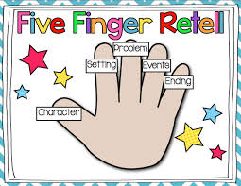
  - How parents can help: After sharing a story, talk about important story elements such as beginning, middle and end. Encourage the child to retell or summarize the reading.

- Craft and Structure
  - What it means: Focus on the specifics of a text – an author’s specific word choices or phrases. Recognize and understand the structure of common types of texts, including storybooks, poems and more
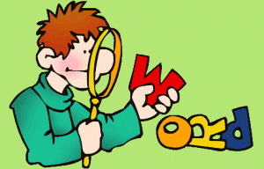
  - How parents can help: During and after reading, call attention to interesting words and phrases. Respond to language, vocabulary and any other ways the author uses language or words to make the meaning of a text interesting, informative, funny or sad.

- Integration of Knowledge and Ideas
  - What it means: Work to compare and contrast details from stories and tell how two texts on the same topic differ
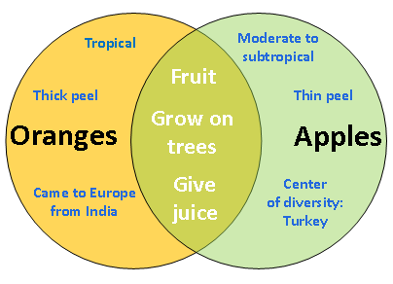
  - How parents can help: Encourage children to describe how illustrations support a story. Read different versions of the same story, talk about similarities and differences between two books. Compare nonfiction and fictional texts. “Let’s look at each book and think about the words used to describe ______. How are the descriptions alike? How are they different?”

- Range of Reading and Level of Text Complexity
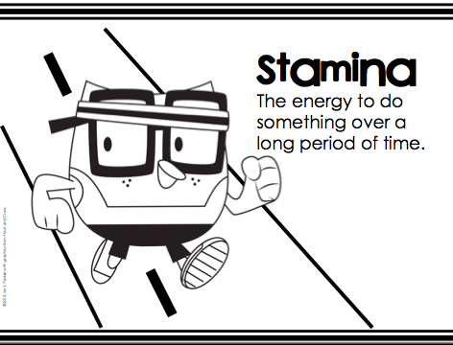
  - What it means: A variety of techniques are used to introduce a range of books and written material to support and challenge a child’s reading level. The ultimate goal is for children to understand what they are reading.
  - How parents can help: Promote a child’s skills by develop reading stamina (ability to “stick with it”). Help children avoid frustration or anxiety about tackling a harder book. Support a reader by talking through things that make a text complex.
Nonfiction (Informational) Text
- Read together and read regularly
- Talk about nonfiction
  - Categorize books
  - Identify differences between fiction and nonfiction
- Look at the parts
  - Identify text features of non-fiction text: table of contents, index, glossary, photographs, charts, captions, sources
  - Share the purpose of each feature
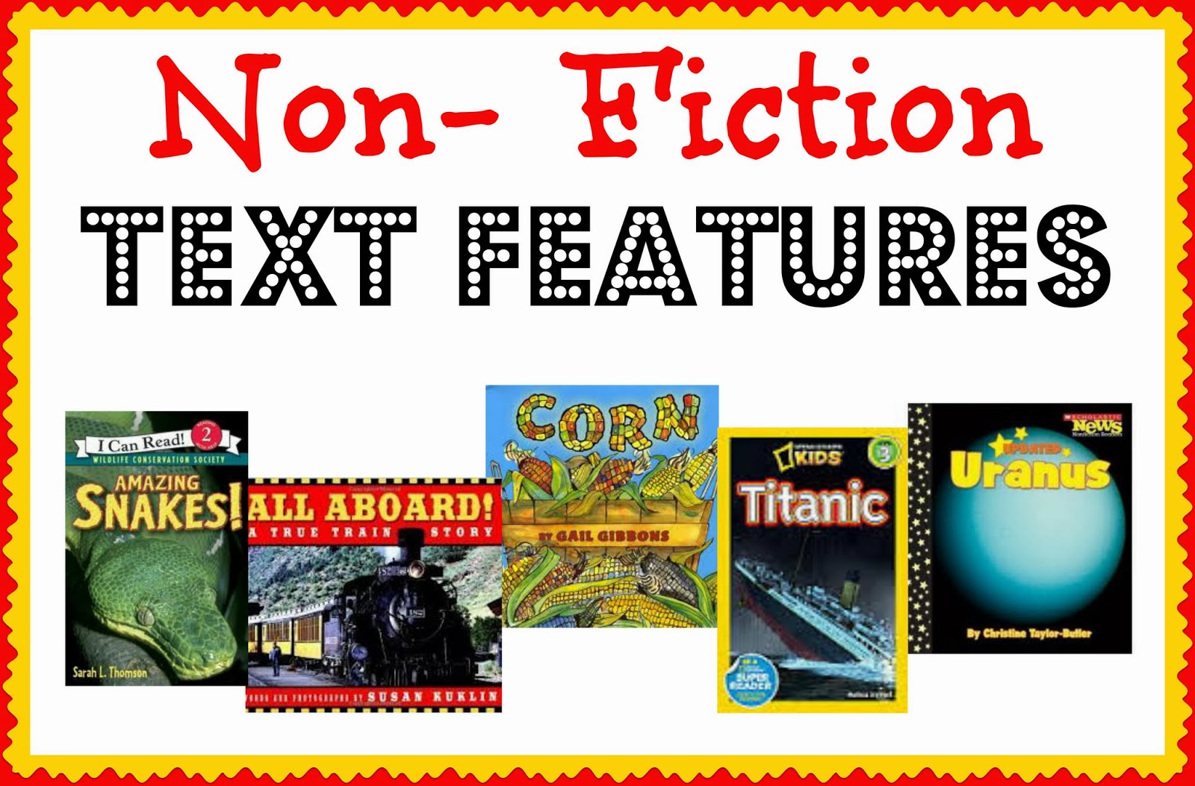
    - Table of Contents – a list of the big ideas within a book and where to find them
    - Index – alphabetical list of topics covered within the book
    - Glossary – key words and definitions located at the back of the book
    - Captions – underneath photographs, figures, maps, charts – give information about what information is presented in a graphic
    - Photos/Charts – information on a topic presented in a visual way
- Be the Reading Boss
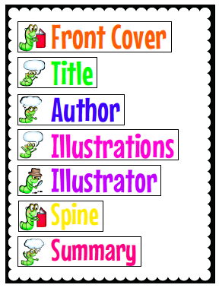
  - Use text features to jump right to specific information
- Take a “book walk”
  - Make predictions about an unfamiliar nonfiction text
  - Scanning and skimming helps set the expectation for reading
- Encourage questions
  - Be an active reader and encourage questions
  - Model behaviors by talking or thinking out loud as you read a text
  - “When I looked at this picture, I asked myself…”
  - Discuss the book together and where you might find answers to some of your questions
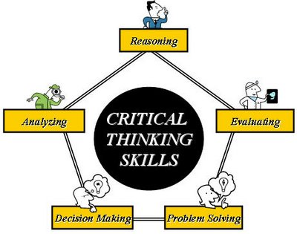
Critical Thinking Skills
- The ability to think deeply about a topic or a book
- Develops and builds through conversations and experiences
- Family read-alouds – tackle more challenging books together
- Share books and reading with your children
- Work through tough reading together – be persistent
- Reflect on reading
- Ask open-ended questions where there can be multiple correct answers
Effective Ways to Engage in Children’s Stories Daily
1.) Create a special daily time to read a book with your child.
2.) Create time for independent reading.
3.) Make the most of quiet times
If there’s a quiet period during the day, bring out a children’s stories and read to your children. For example, while the kids are finishing off their lunch, read a book to them at the table. (If your house is anything like ours, the adults are always finished eating before the children – unless it’s a meal of noodles!)
4.) Play children’s stories on CD
5.) Take a book outside … and read it there!
6.) Develop extension activities which are related to a story.
7.) Make up a bag of books to keep in the car.
8.) Carry a book in your bag.

