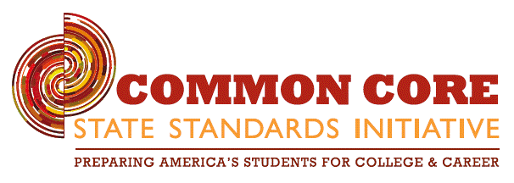

You are invited to:

* Learn what effective reading strategies are
* Learn how to use effective reading strategies at home
* Understand how to ask questions that foster comprehension, analysis and reflection
* Experience sample reading lessons that can be done at home

**2 Service Hours will be given for attendance**

## **Wednesday, March 26**

7:00-8:00pm

Common Core

K-8 Parent Workshop

Questions: e-mail nscheppers@school.stjohneudes.org

# St. John Eudes Science Lab