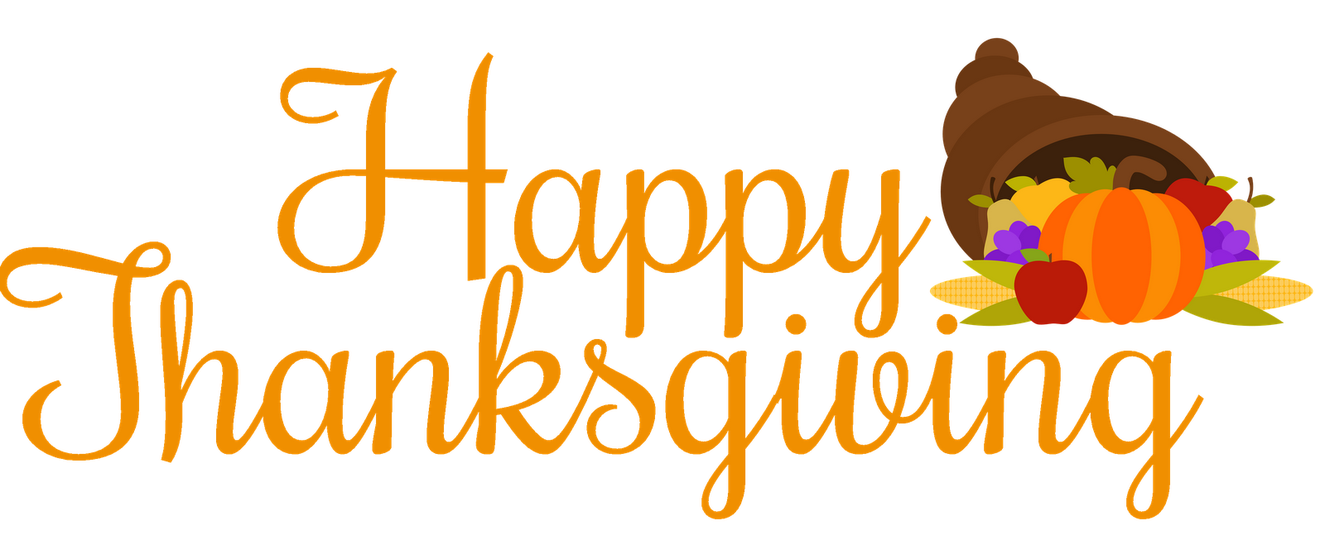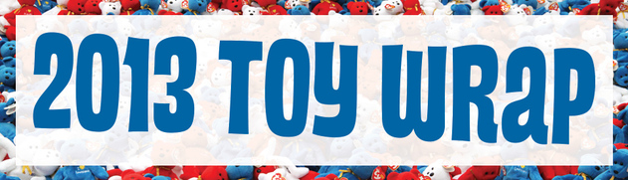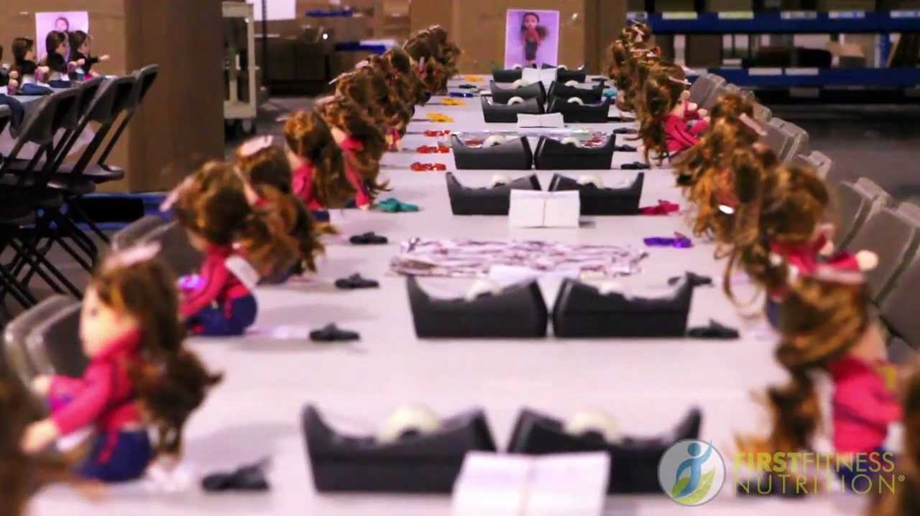

from the 2013-2014 St. John Eudes chapter of NJHS: Justin, Cecil, Daniel Setiabudi, Matthew, Daniel Singontiko, Jeremy, Olivia, Kawika, Natalia, Carlos, Daniel Ferreiro, Jessica, Michael, Thayer, Caleb, Kelan, Kristina, Bianca, Charlisse, Jennifer, Madison and Ms. Scheppers

Thanks to our NJHS member, *Kristina Mendoza*, and her research NJHS has chosen their first service project of the year. The members of the St. John Eudes chapter of NJHS will be volunteering alongside hundreds of other volunteers at the 2013 Children’s Hunger Fund Toy Wrap. As NJHS members the students are committed to quality service that serves both the parish and the community and we are all excited to take part in this event.

NJHS member parents and siblings are encouraged to attend. Please register online if you plan to attend.

Please refer to the NJHS web page for more information <http://sje6thgr.weebly.com/chf-toy-wrap.html>

NJHS Chapter Meetings the first Tuesday of EVERY month in the 6th Grade Room:

**November 18 – EXTRA Mtg.**

**December 3**

**January 7**

**February 4**

**March 4**

**April 1**

**May 6**

**June 3 (7th grade only)**

# Children’s Hunger Fund Toy Wrap

* **Date:** Wednesday, December 4th
* **Time:** 5:45-9:00pm
* **Location:** Children's Hunger Fund 13931 Balboa Blvd. Sylmar, CA 91342
* **Transportation:** Carpool
* **Cost/Price:** FREE
* Permission slips due **Nov. 13** to Mrs. Crow in the business office

### Toy Wrap Details

**What is the Children’s Hunger Fund (CHF)?**

Children's Hunger Fund is a Christian 501(c)3 nonprofit organization that works to alleviate the suffering of children in impoverished regions across America and around the world. Through strategic partnerships in targeted communities, CHF works to improve the lives of poor children and their families comprehensively, meeting their physical, emotional, and spiritual needs.

Since CHF began in 1991, our supporters have helped us distribute more than $927 million in food and other resources to serve the needs of more than 10 million children in thirty-five U.S. states and seventy-two countries worldwide.

Since CHF's inception, an average of 99% of our total contributions have been used for programs serving the needs of children.

Check out the CHF webpage: <http://childrenshungerfund.org/help-a-child/>

**What is the Toy Wrap?**

CHF gives new toys to needy children. It’s a way to show love and bring joy to the precious little ones of our communities.  This year, hundreds of compassionate volunteers like NJHS will join Children’s Hunger Fund to wrap tens of thousands of toys for children who might otherwise go without this Christmas. We can be the difference between despair and hope!

National Junior Honor Society

2013-2014

November 2013

NJHS, St. John Eudes