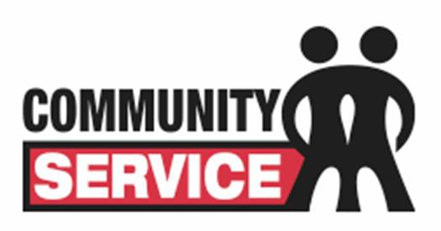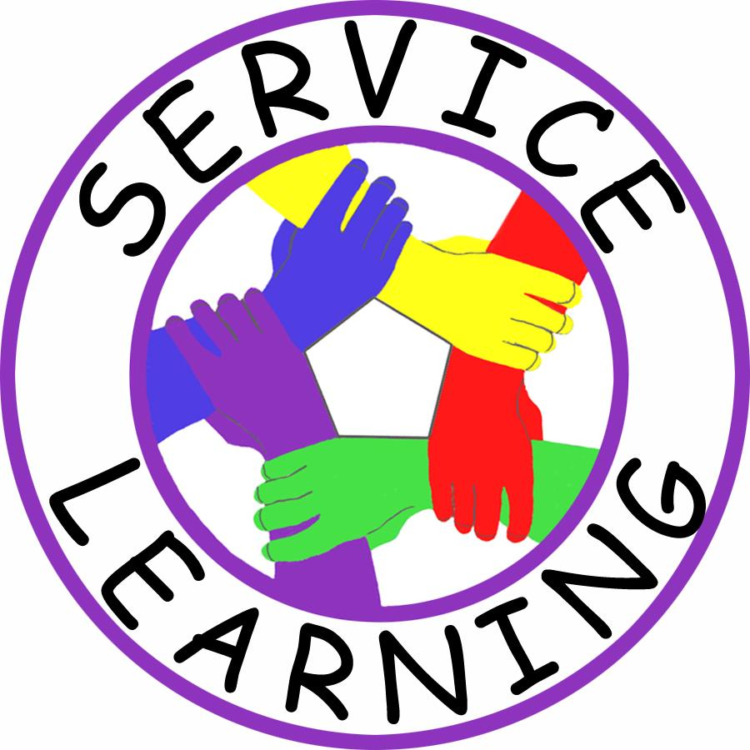

*“We make a living by what we get, but we make a life by what we give.”*

*– Winston Churchill*

Junior High students are required to complete service hours every year.  This is an opportunity for students to act in Jesus' image as a committed follower of Christ.

Being a Christian, and a disciple of Christ calls us to live our lives according to the example and instructions Jesus himself gave us.  This is our mission as a Church and School, and it's a BIG responsibility!

One of the most important lessons Jesus taught us was that we must be willing to be a servant to all people in His name.  This means that we must actually *DO something* to be a disciple of Christ!  **By doing parish and community service, we demonstrate a willingness to show Christian responsibility to our mission.**

All St. John Eudes Junior High students are required to complete a minimum amount of service each year.  This means that the students should participate in some type of parish or community service each academic year to fulfill their annual requirement.

An experience of service might be helping at Share-A-Lunch or a nursing home one time.  Previous students have earned service hours by volunteering at the SJE Carnival, Sandwich Sunday, the Los Angeles Animal Shelter, a local Soup Kitchen, or by participating in a local 5K and fundraising.  There are plenty of service opportunities out there here at St. John Eudes parish and throughout the Los Angeles and San Fernando Valley communities.

# Service Hours

### Reminders

Nov. 9

St. John Eudes Parish “Clean House Day” 11:00am-1:00pm

Volunteers **MUST** register with the office ahead of time.

Lunch will be provided.

(818) 341-1455

* Required Service Hours by Grade Level: 6th - 10 Hours, 7th - 15 Hours, 8th - 20 Hours
* Service Hours are due MAY 9, 2014, Service hour forms are available in the front office
* All Service must be **pre-authorized** by Mrs. Danowitz.
* Permission must be given by the parent **BEFORE** service begins.
* Keep a record of your service on the form below & return it to your homeroom teacher when you are finished.
* Always have an authorized chairperson sign off on your completed service hours wherever you volunteer.

Reminders about Service Hours:

National Junior Honor Society

NJHS Chapter Meetings the first Tuesday of EVERY month in the 6th Grade Room:

**November 5**

**December 3**

**January 7**

**February 4**

**March 4**

**April 1**

**May 6**

**June 3 (7th grade only)**

2013-2014

October 2013

NJHS, St. John Eudes