Name:____________________

Dress Up Day Survey

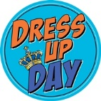

1. What dress-up days would you like to see this year?

Please circle the letter(s) of all the dress-up days that you would participate in?

1. Crazy Hat Day
2. Crazy Hair Day
3. Pajama Day
4. Twin Day
5. Grade level color day (each grade level wears the same color as their equipment)

Please list any other dress-up days you would like to participate in this year.

1. ___________________________________________________________________________
2. __________________________________________________________________________
3. _________________________________________________________________________

Name:____________________

Dress Up Day Survey

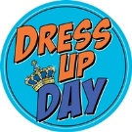

1. What dress-up days would you like to see this year?

Please circle the letter(s) of all the dress-up days that you would participate in?

1. Crazy Hat Day
2. Crazy Hair Day
3. Pajama Day
4. Twin Day
5. Grade level color day (each grade level wears the same color as their equipment)

Please list any other dress-up days you would like to participate in this year.

1. ___________________________________________________________________________
2. __________________________________________________________________________
3. _________________________________________________________________________