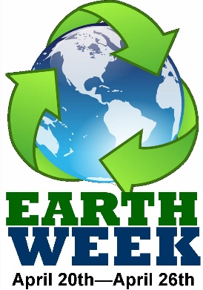

William Green is proud to present Earth Week! Student Council looks forward to your participation in the events below! Remember to complete the Earth-Day Challenge to join the “Be Green at Green Club”. In addition, Student Council will also be passing out “Green Cards” for students they observe being Green, Picking up trash and conserving electricity and water. Look to your Stay Green Challenge for more ideas on how to “Be Green at Green”.

**Dress-up Days and Activities:**

Monday April 20-Show your support for Earth Week and wear Blue.

Tuesday April 21- Come join Student Council at 3rd-5th grade morning recess on the basketball courts to play an Earth Day Game.

Wednesday April 22- Earth Day- Honor Earth Day by helping Student Council keep our campus clean and picking up at least 5 pieces of trash.

Thursday April 23- Come Visit the Earth Day Booth in the Cafeteria during your Lunch Recess to create a Green Pledge!

Friday April 24-Be Green and wear Green!

