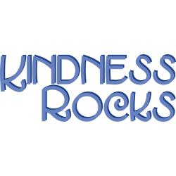

Dear Parents,

William Green’s Student Council is proud to present The Great kindness Challenge. The challenge will run the week of January 26-30th. Each day there will be a different challenge given to the students. In addition, there will be a creative writing competition for grades 3-5 judged by the teachers and adminstration.Flyers will go out explaining the competition. We look forward to your participation. Thanks for your support!

**Dress-up Days:**

Monday January 26- Be as kind as your heart and wear Red

Tuesday January 27- Students please come visit the Kindness Booth at Lunch and participate in a kindness activity.

Wednesday January 28- Score points by helping others and wear a sports team’s jersey or shirt of your choice.

Thursday January 29- Be kind and come show your moves at Lunch with President Dasean’s dance party!

Friday January 30- Green Kids are Kind Kids please wear green!

