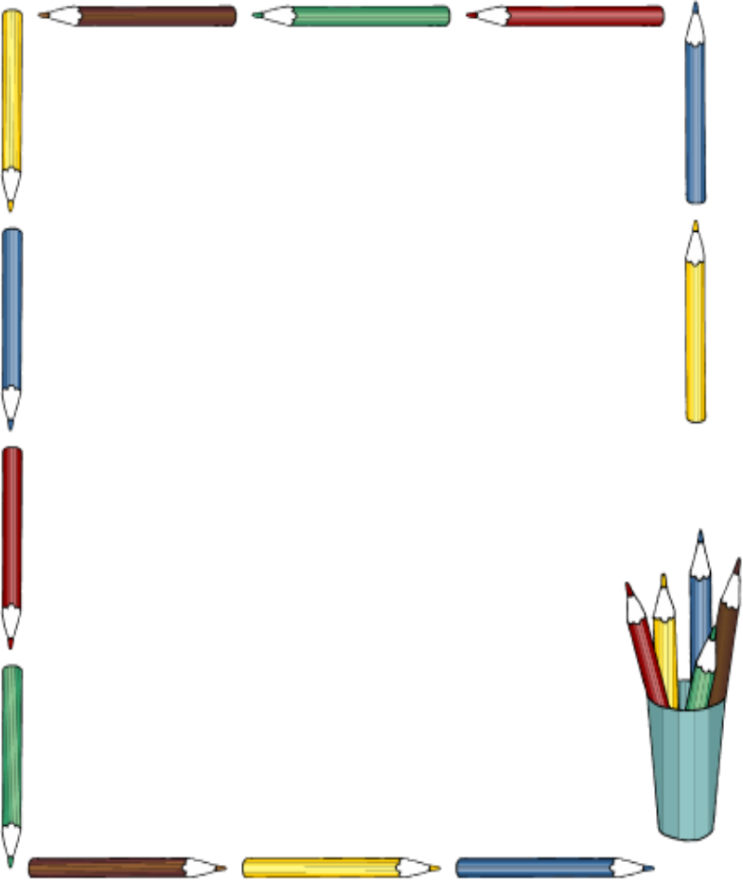



**Common Core English Language Arts Workshop Series**

**WHO:** Parents of students in Grades 3-5

**WHAT:** Parents will receive a series of seminars on the ELA Common Core Standards and complete a fun Activity.

**WHEN:** Wednesday January 14th from 5:30-7:00 PM, February 18th and April 8th.

\***Please join us for dinner. It starts at 5:30**

**WHERE: William Green Elementary Room 34**

**RSVP to room 34 by Wednesday January 7th**

ELA Common Core Parent Workshop- Wednesday January 14

Students’ Name: ______________ Grade/Teacher:__________

Yes I am attending_______ No I am not attending_______

_______ Number Attending Translation Needed_________