Parent Workshop 3

Reading and Writing Strategies

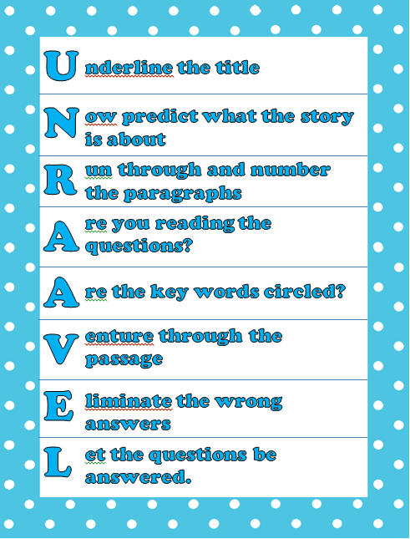

William Green Elementary

Presenter: Lisa Baggio

April 8, 2015