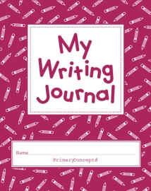

Steps of power writing:

1. Put two topics on the board. Students can choose one topic.
2. Call on students to provide nouns, verbs, and or adjectives that describe the topic.

Example: Spring Break

Vacations

1. Have students close their eyes and visualize what they want to write.
2. Have students write a goal of how many words that think they can write in the specified time period.
3. Students will then turn to a partner and share what they will write about
4. Have your students lift their pencils and say:

I am a writer

I am a powerful writer

I will write as much as I can As well as I can until the time is through

1. Give the students between 3-5 minutes to write.
2. Have students count up their words and see if they met their goal.
3. Editing: Have the students do magic headphones editing-Put fingers in their ears and edit their work. You can give them an area to focus on.

