Student Council Agenda
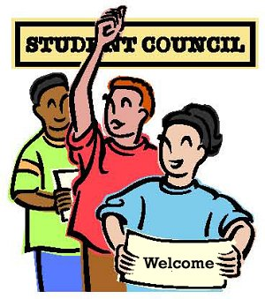

Thursday April 30
Lunch: 12:15-1pm

1. Welcome and Introduction from Josie- Hello, everyone and welcome! Today’s meeting will focus on Teacher Appreciation and the College-going culture

2. Roll Call of Attendance: Secretary takes Attendance

3. Historian explains the: Minutes from the last meeting:

Treasure: -BOX Top Committee-No Announcements
4. President: The following
Specific Agenda Items:
- Book Fair: Deliah Melanie, Octavio Geremy, Gabriel
- Teacher Appreciation Week: Teacher Signing Paper, Card-making booth at lunch on Tuesday, Chocolate Monday- Chocolate grams Tuesday-booth Wed-Wear Blue to show your love for your teacher! Announcements: Saide-Monday JOJo Tomorrow Tuesday: Isaac Wed: Octavio Thur: Nathan
- COPA
- College-Going Culture- Saide, Dasean, Jojo, Marilyn, Erandi, Isaac, Juan, Josie, Anthony-
7. Vice President Announces:
Jog-a-thon is coming up. Any ideas that we can do during the week of the jog-a-thon
Ideas:
8. Date of Next meeting:
Thursday May 8th

